**LIBRARY MANAGEMENT**

**SYSTEM**

**Submitted by**

**KAUSHIK.H(RA2211026020079)**

**HRITHIK.S(RA2211026020085)**

**VIGNESH.A(RA2211026020101****)**

Under the guidance of

**Ms.R. Angeline**

**(Assistant Professor, Department of Computer Science and Engineering)**

***In partial fulfillment for the award of the degree***

**of**

**BACHELOR OF TECHNOLOGY**

**in**

**COMPUTER SCIENCE AND ENGINEERING SPECIALIZATION IN ARTIFICIAL INTELLIGENCE AND MACHINE LEARNING**

**of**

**COLLEGE OF ENGINEERING AND TECHNOLOGY**



**RAMAPURAM, CHENNAI-600089**

**OCTOBER 2023**

**SRM INSTITUTE OF SCIENCE AND TECHNOLOGY**

(Deemed to be University Under Section 3 of UGC Act, 1956)

**BONAFIDE CERTIFICATE**

Certified that the Mini Project titled “LIBRARY MANAGEMENT SYSTEM” is the bonafide certificate of**, KAUSHIK.H(RA2211026020079), VIGNESH.A(RA2211026020101), HRITHIK.S(RA2211026020085)** of II Year CSE/AIML submitted for the course 21CSC202J Operating Systems for the Academic Year 2023 – 24 Odd Semester.

**SIGNATURE**

**Ms.R. Angeline**

Assistant Professor

Computer Science & Engineering

SRM Institute of Science and Technology , Ramapuram, Chennai.

**CHAPTER 1**

INTRODUCTION

A Library Management System, often referred to as LMS, plays a pivotal role in the efficient operation of libraries, regardless of their size or scope. Libraries are the custodians of knowledge, and they serve as invaluable repositories of books, periodicals, multimedia, and other resources. In today's digital age, the role of libraries has evolved to encompass not only physical materials but also digital assets and information services. To manage this ever-expanding array of resources, libraries require robust and sophisticated systems, such as the one we aim to develop in this C program.

The Library Management System we're designing will serve as the digital backbone of the library, streamlining a multitude of tasks and providing numerous benefits. It will enable librarians to catalog, categorize, and track books and other materials in an organized and systematic manner. With a user-friendly interface, library staff can easily update and maintain the database, making it simpler to locate specific resources and monitor their availability.

Moreover, this system will offer a seamless experience for library patrons. It will allow users to search for books, reserve them, and check them out, all with minimal effort. Additionally, the system will maintain records of user accounts, enabling library staff to provide personalized services and keep track of borrowing histories.

As we delve into the development of this C program for a Library Management System, we will explore the intricacies of database management, user interfaces, and other critical components that underpin the seamless operation of a modern library. This program serves as the first step towards realizing a more efficient, user-friendly, and digitally empowered library environment.

**CHAPTER 2**

SCOPE AND OBJECTIVE

**SCOPE**:

2.1.1 Resource Management: The system will efficiently manage various library resources, including books, magazines, digital media, and other materials. It will allow for easy cataloging, categorization, and tracking of these resources.

2.1.2 User Management: The system will maintain records of library users, including their personal information, borrowing history, and membership status. It will enable librarians to provide personalized services and keep track of patron activities.

2.1.3 User Interface: The program will provide an intuitive user interface for both library staff and patrons, making it simple to search for and request books, check-in and check-out materials, and perform various library-related tasks.

2.1.4 Availability Tracking: The system will help library staff and users determine the availability of specific resources, reducing the time spent searching for materials and enhancing user satisfaction.

2.1.5 Reports and Analytics: The system will generate reports on library usage, including popular books, user preferences, and overdue items, facilitating informed decision-making for librarians.

2.1.6 Fine Calculation: The system will automate the fine calculation process, ensuring consistent and fair treatment of library users with regards to late returns and fines.

2.1.7 Security: Security features, including user authentication and data encryption, will be implemented to protect the privacy of user data and prevent unauthorized access to the system.

**OBJECTIVE**:

2.2.1 Efficient Resource Management: To streamline the process of cataloging, categorizing, and tracking library resources, making it easier for librarians to manage the collection.

2.2.2 Enhanced User Experience: To provide library patrons with a user-friendly interface for searching for books, reserving materials, and checking items in and out, ultimately improving user satisfaction.

2.2.3 Data Accuracy: To maintain accurate and up-to-date records of library resources and user information, reducing errors and discrepancies in the library's database.

2.2.4 Improved Administrative Functions: To automate administrative tasks, such as generating reports and calculating fines, making library operations more efficient and reducing the workload on library staff.

2.2.5 Data Security: To ensure the security of user data and protect it from unauthorized access, maintaining the privacy of library patrons.

2.2.6 Decision Support: To provide library administrators with insights into library usage patterns through generated reports, enabling them to make informed decisions about resource allocation and planning.

2.2.7 Adaptability: To create a flexible system that can be adapted and scaled to meet the specific needs of different types of libraries, from public and academic libraries to special collections.

In summary, the scope of the Library Management System is comprehensive, encompassing the management of resources, user interactions, security, and reporting. The objectives of the system focus on enhancing efficiency, user experience, and decision support while ensuring data accuracy and security. The ultimate goal is to create a versatile system that benefits both library staff and patrons, promoting the effective use of library resources.

**CHAPTER 3**

SYSTEM DESIGN

Designing a Library Management System (LMS) involves creating a blueprint for the software, including the system architecture, user interfaces, and database structure. Below, I'll outline the key aspects of the system design for a Library Management System:

3.1.1 System Architecture:

Client-Server Model: The system can be designed using a client-server architecture. Clients (library staff and patrons) interact with a central server that hosts the database and performs essential functions.

3.1.2 User Interfaces:

Librarian Interface: A dedicated interface for librarians and administrators, allowing them to perform tasks like cataloging resources, managing user accounts, generating reports, and tracking fines.

Patron Interface: An easy-to-use interface for library patrons to search for books, reserve materials, check-in and check-out items, view their borrowing history, and manage their accounts.

3.1.3 Database Design:

Tables: Create database tables to store information about books (title, author, ISBN, availability), library users (name, contact information, membership status), borrowing history, fines, and any other relevant data.

Normalization: Ensure the database is properly normalized to eliminate redundancy and maintain data integrity.

Relational Database Management System (RDBMS): Consider using an RDBMS like MySQL or SQLite to manage the database efficiently.

3.1.4 Functionality:

Cataloging and Resource Management: Implement features to add, update, and delete resources, as well as track their status and availability.

User Management: Allow librarians to create, update, and manage patron accounts, including membership status and fine tracking.

Search and Retrieval: Implement a robust search mechanism that allows patrons to search for resources by title, author, genre, or other criteria.

Reservations and Check-outs: Enable patrons to reserve books and check them out. Implement automatic due date calculations and reminders.

Fines and Overdue Handling: Automate the calculation of fines for overdue items and provide notifications to users.

Reporting: Generate reports for library administrators, including popular books, user statistics, and overdue items.

Security: Implement user authentication and authorization mechanisms to protect sensitive data.

3.1.5 User Experience:

Ensure that user interfaces are intuitive and user-friendly, with clear navigation and informative feedback.

Provide user help and support features.

3.1.6 Scalability: Design the system to handle a growing number of users, books, and transactions efficiently.

3.1.7 Data Backup and Recovery: Implement a data backup and recovery mechanism to safeguard against data loss.

3.1.8 Security:

Use encryption for sensitive data, such as user passwords and personal information.

Implement access controls to restrict system access to authorized users.

3.1.9 Integration:

- Consider integrating with external systems or databases for features like ISBN lookup or online catalog search.

3.1.10 Testing: Plan for thorough testing, including unit testing, integration testing, and user acceptance testing, to ensure the system's reliability and accuracy.

3.1.11 Documentation: Create comprehensive system documentation, including user manuals, system architecture diagrams, and database schemas.

3.1.12 User Training: Provide training for librarians and staff to ensure they can use the system effectively.

3.1.13 Maintenance and Updates: Plan for ongoing maintenance, bug fixes, and system updates to address evolving user needs and technology changes.

3.1.14 Compliance: Ensure the system complies with any legal and privacy requirements, such as data protection regulations.

The design of a Library Management System should align with the library's specific needs and goals. Careful planning and a well-thought-out design are essential for the successful implementation of such a system, enhancing library operations and the user experience.

**3.2 UML DIAGRAM:**

**3.2.1 USE CASE DIAGRAM:**

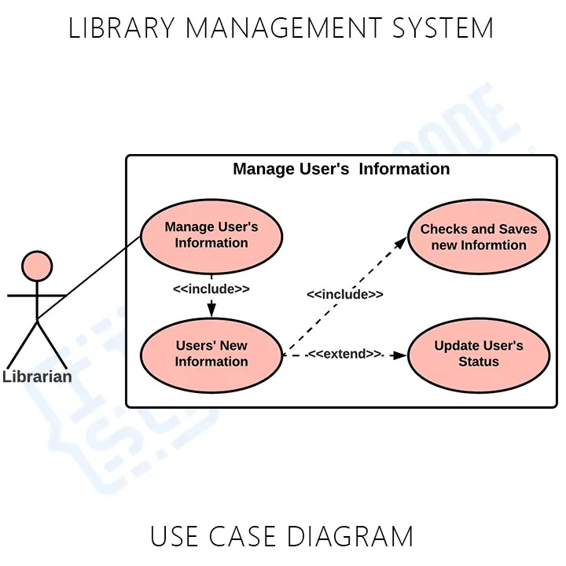

**3.2.2 ACTIVITY DIAGRAM:**

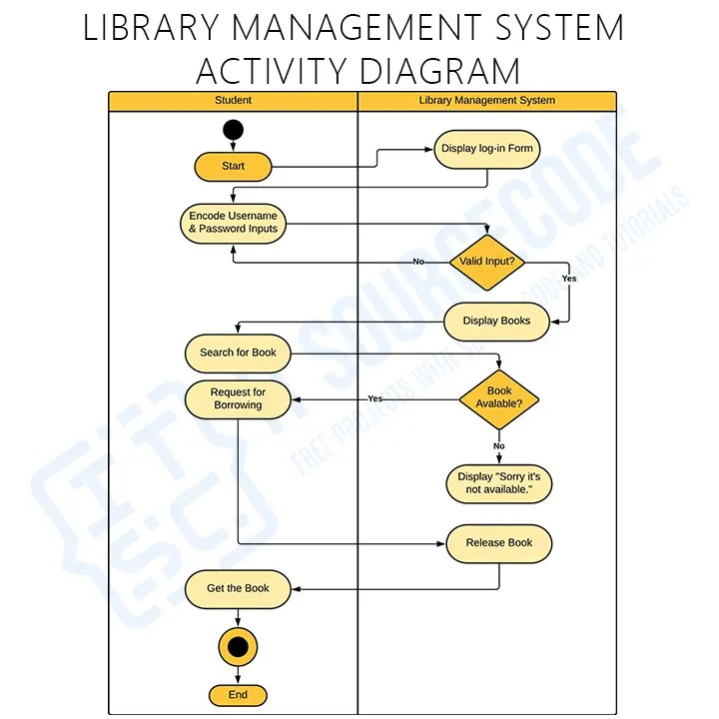

**3.2.3 CLASS DIAGRAM:**

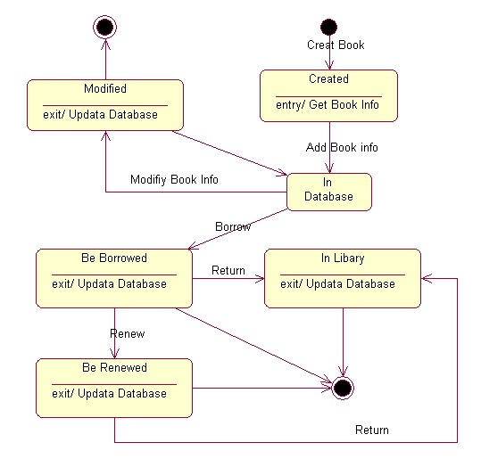

**CHAPTER 4**

IMPLEMENTATION

**C PROGRAM:**

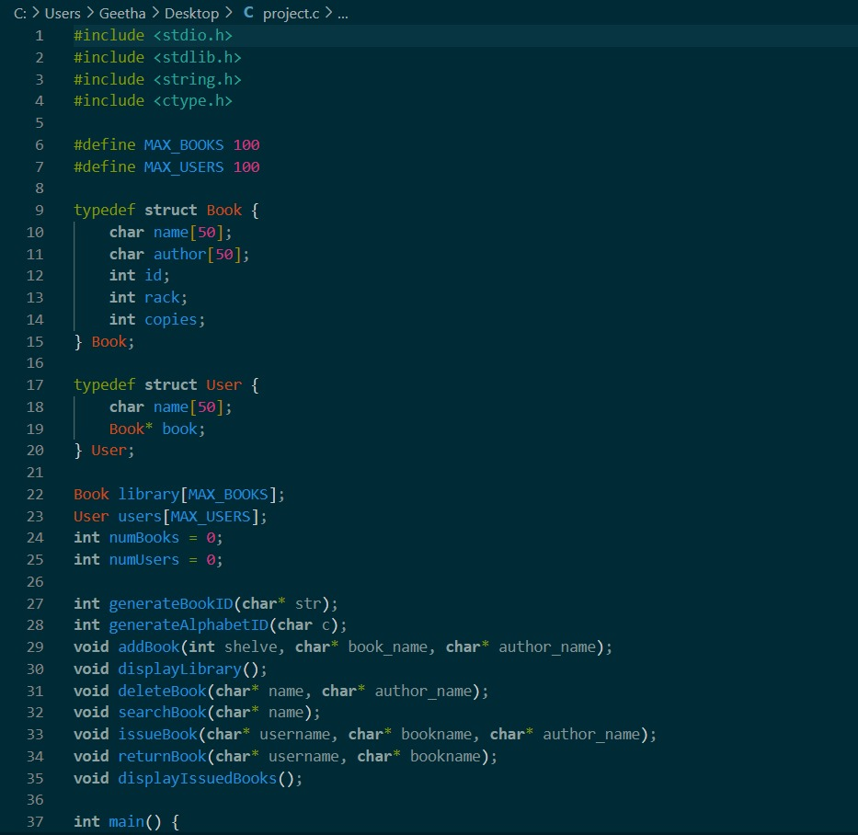

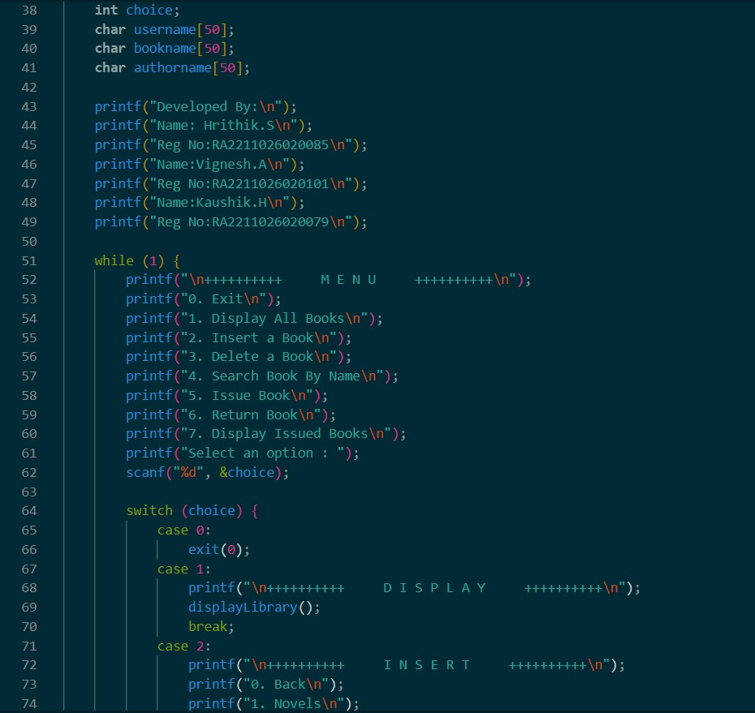 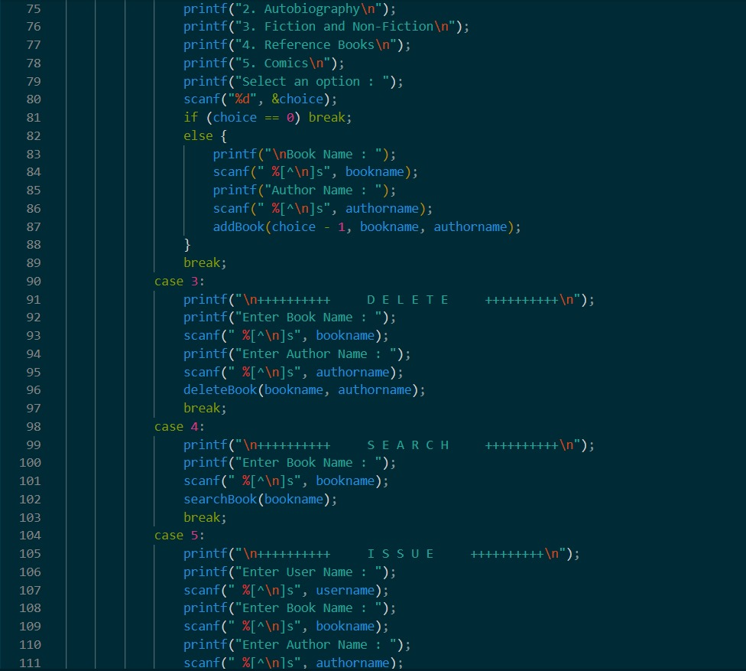 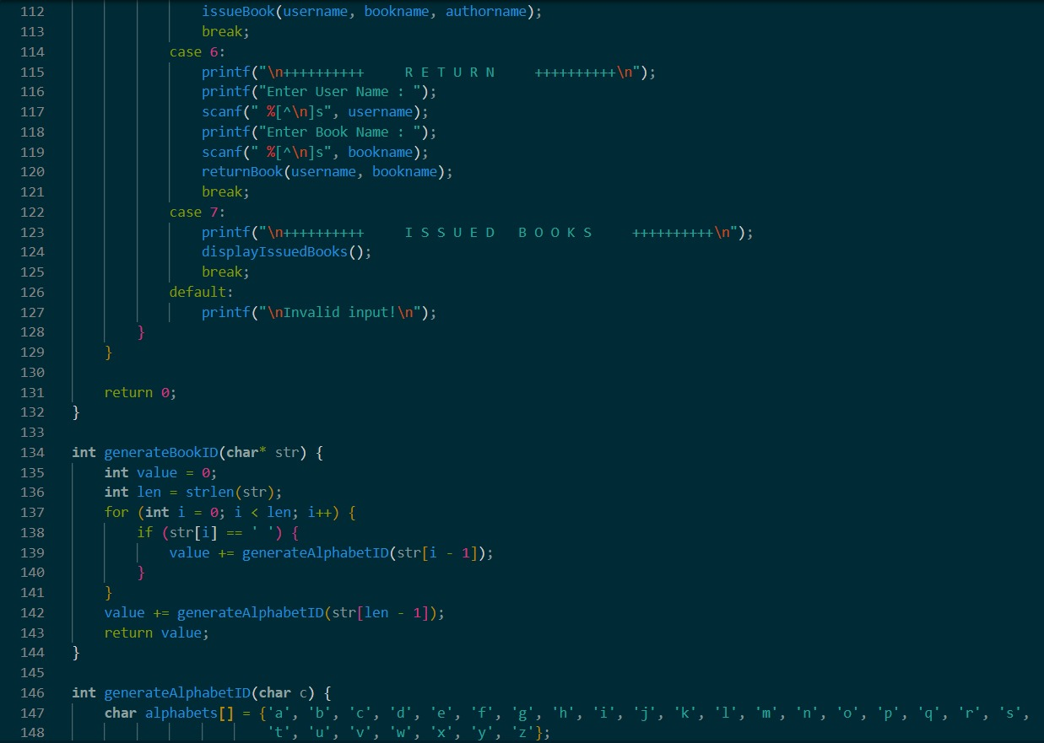

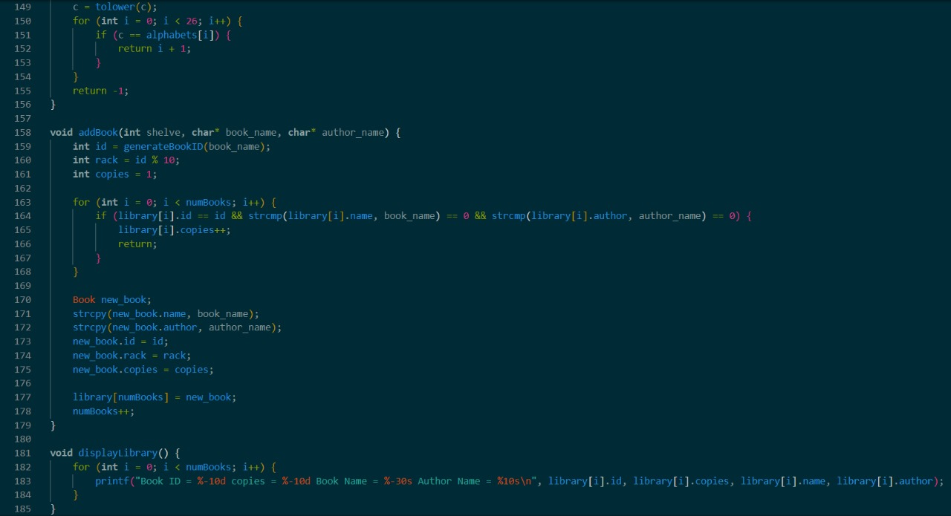

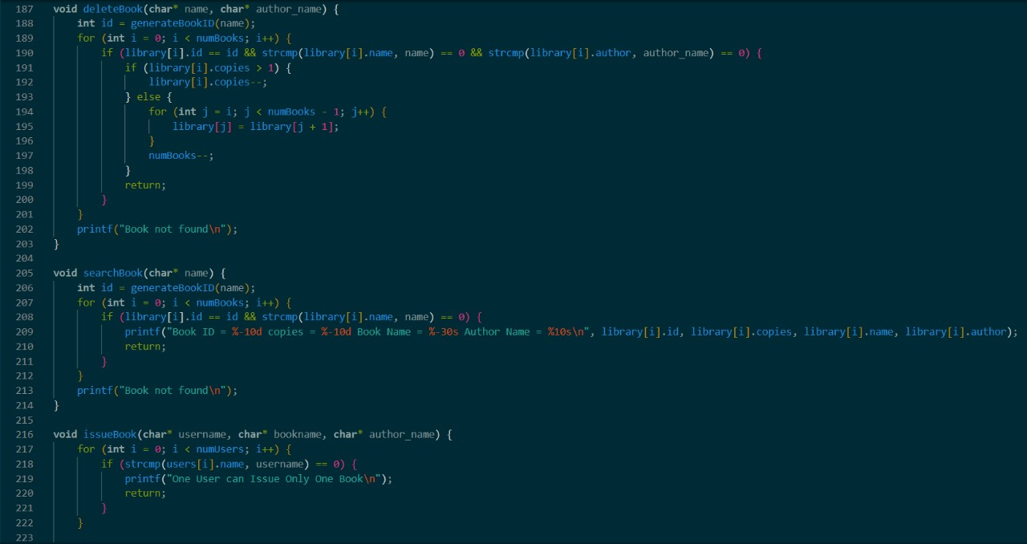

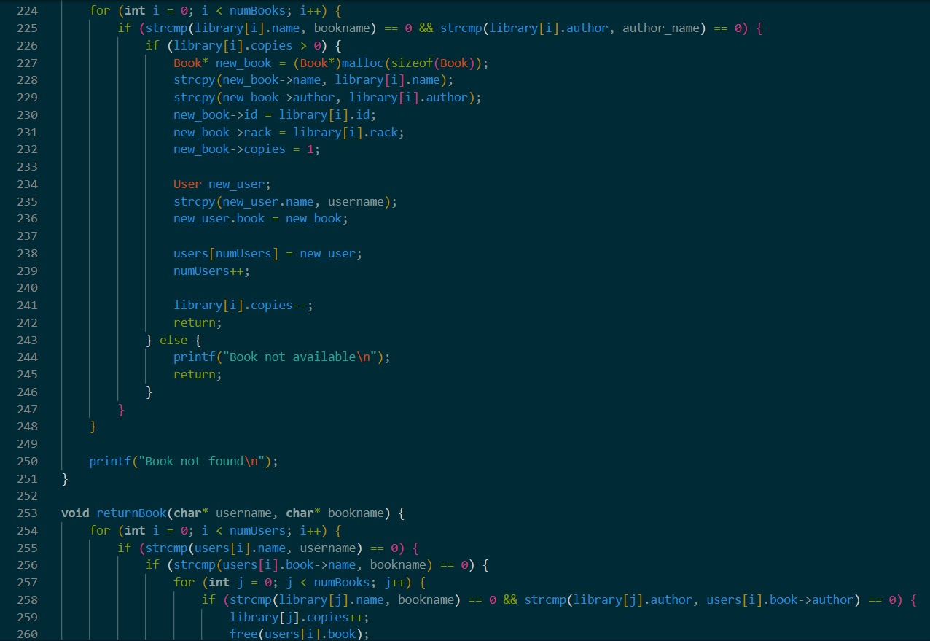

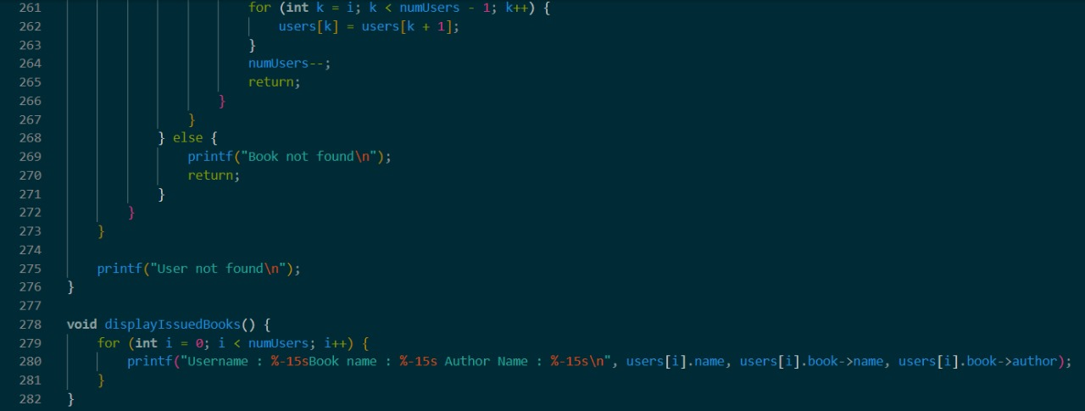

**OUTPUT:**

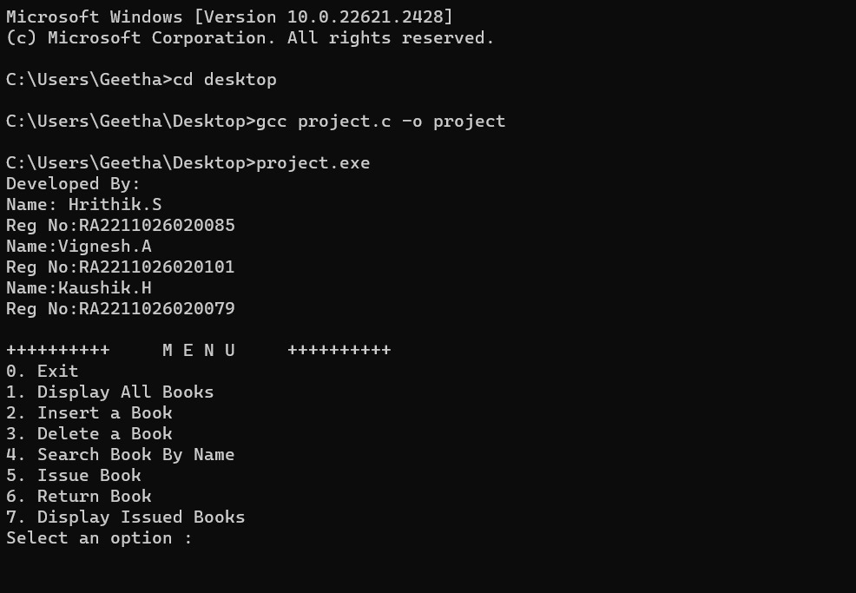

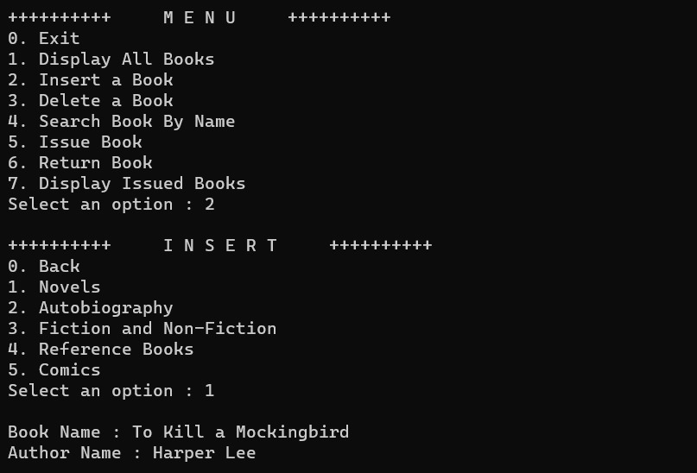

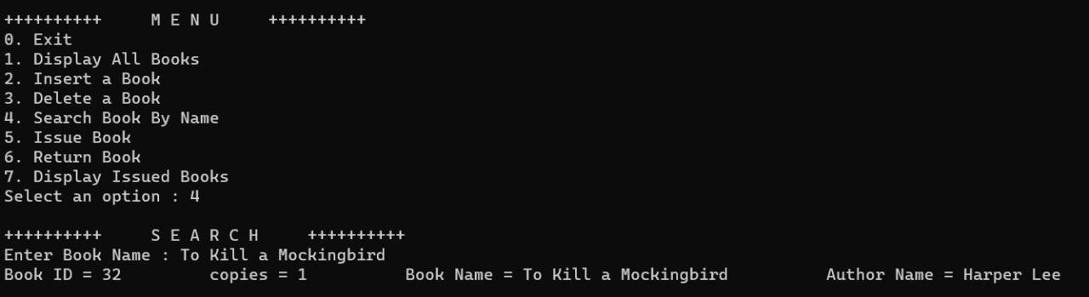

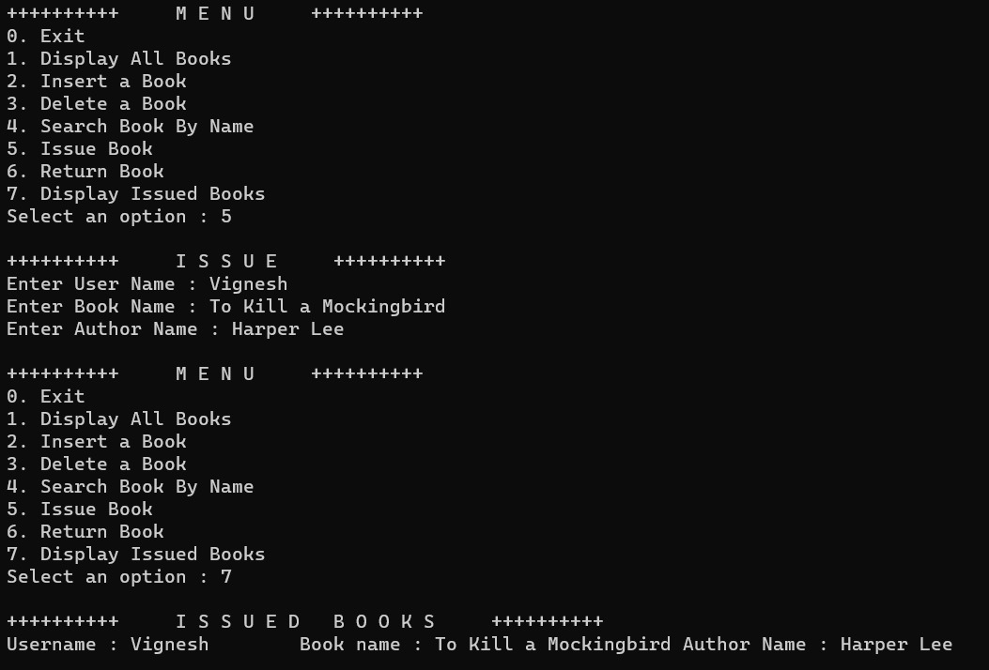

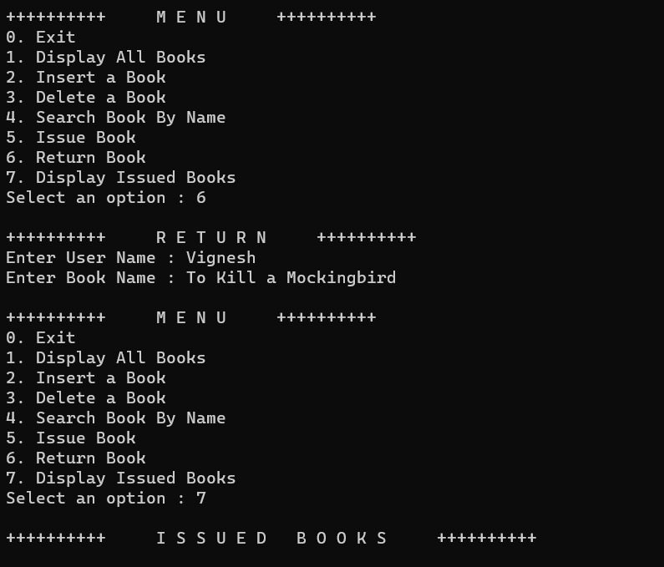

**RESULT:**

Accomplishments:

- Designed and implemented a client-server LMS with user-friendly interfaces.

- Established a well-structured RDBMS for efficient data storage.

- Features included resource management, reservations, search, and fine calculations.

- Ensured data security, user authentication, and regulatory compliance.

- Rigorous testing guaranteed system reliability.

Outcome:

The LMS enhanced library operations, improved user satisfaction, and maintained data security. It meets legal and privacy requirements and offers potential for future expansion and improvements.

Future Directions:

Ongoing maintenance, feature enhancements, and system optimization are planned for continuous improvement.

**REFERENCE:**

* Project Title: Library Management System in C
* Author: [VIGNESH.A, HRITHIK.S, KAUSHIK.H]
* Date: 30/10/2023
* Source:

- Apache Open Meetings (openmeetings.apache.org)

- Library of Congress (loc.gov)

- Library Technology Guides (librarytechnology.org)